1. Create an html page to display the following nested list  
   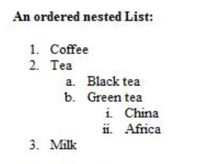

Answer:

<html>

<head>

<title> </title>

</head>

<body>

<h2> An orderd nested List: </h2>

<ol>

<li>Cofee</li>

<li>Tea</li>

<ol type="a">

<li>Black tea</li>

<li>Green tea</li>

<ol type="i">

<li>China</li>

<li>Africa</li>

</ol>

</ol>

<li>Milk</li>

</ol>

</body>

</html>

Output:

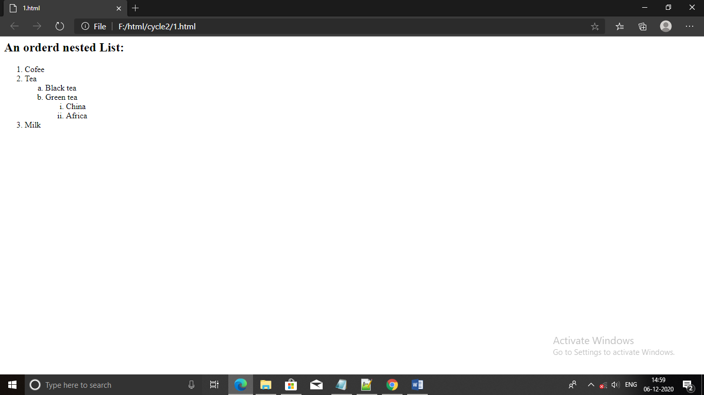

1. Create links to three different pages on three different websites that should all open in a new window.

Answer:

<html>

<head>

</head>

<body>

<br><br>

<a href="https://www.nptel.ac.in/" target="_blank">NPTEL Online Course</a>

<br><br>

<a href="http://www.coursera.org/" target="_blank">Corsera</a>

<br><br>

<a href="https://github.com/" target="_blank">GitHub</a>

</body>

</html>

Output:

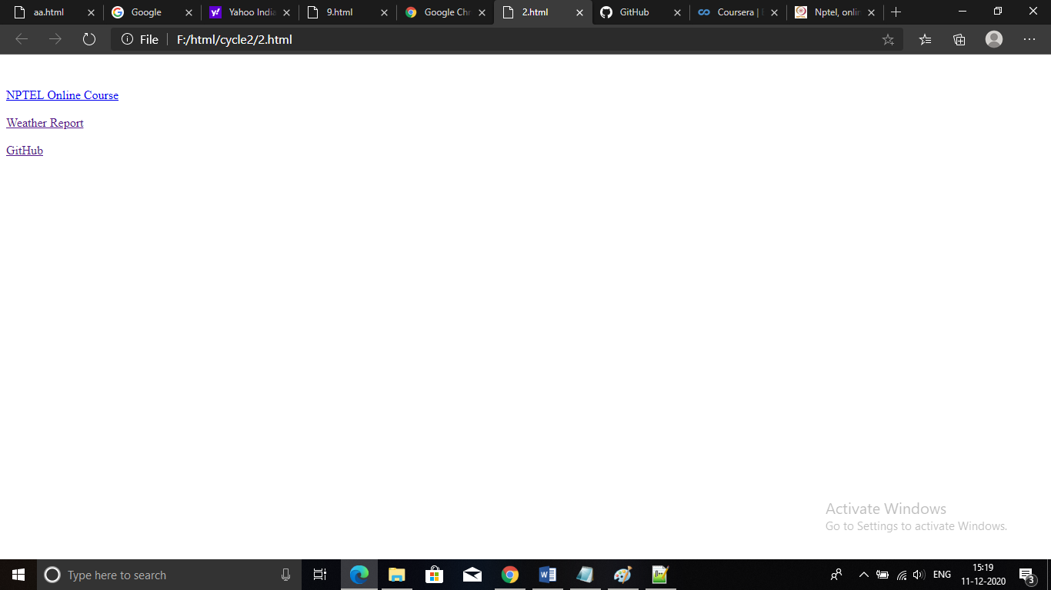

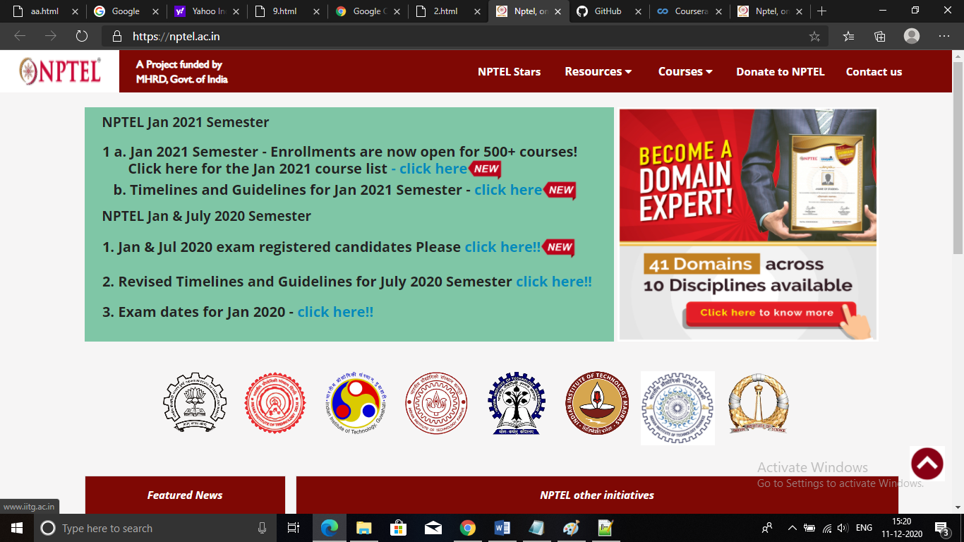



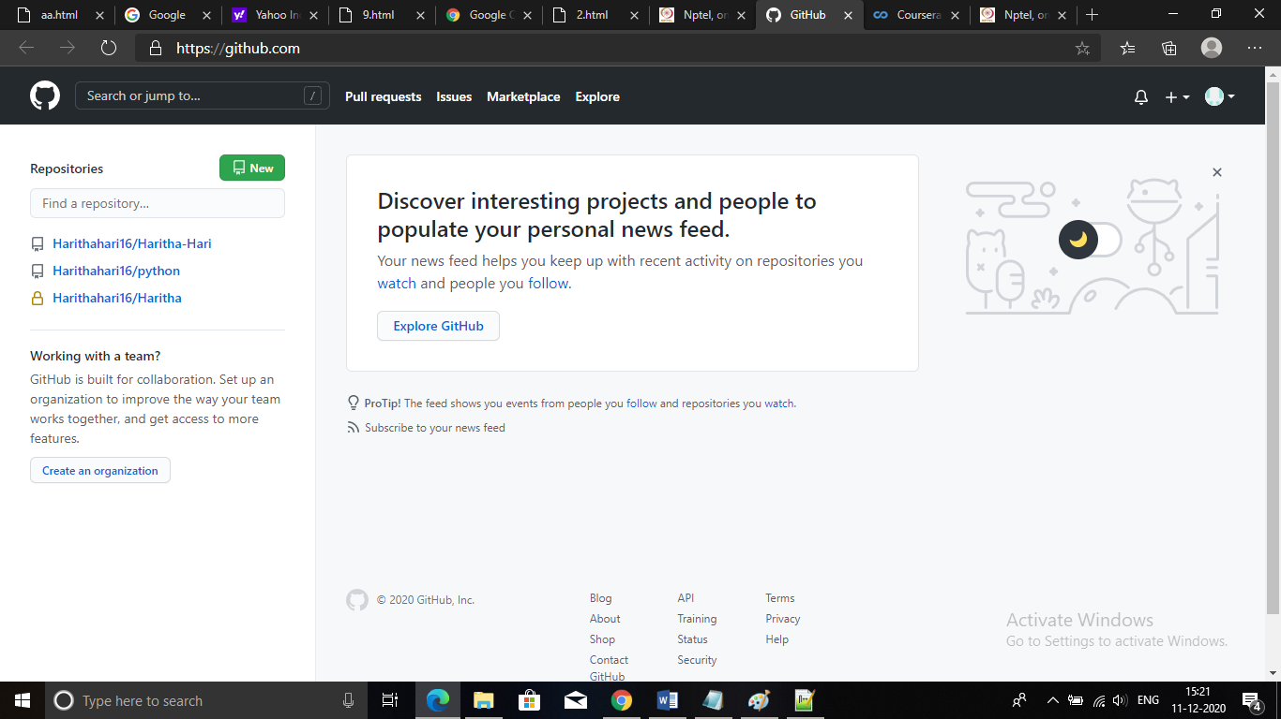

1. Create a page with a link at the top of it that when clicked will jump all the way to the bottom of the page.

Answer:

<html>

<head>

<title> </title>

</head>

<body>

<a href="#history">History</a>

<a href="#markup">markup</a>

<a href="#varification">varification</a>

<a href="#see">see also</a>

<span id="history">

<h2>History</h2>

Hypertext Markup Language (HTML) is the standard markup language for documents designed to be displayed in a web browser. It can be assisted by technologies such as Cascading Style Sheets (CSS) and scripting languages such as JavaScript.

Web browsers receive HTML documents from a web server or from local storage and render the documents into multimedia web pages. HTML describes the structure of a web page semantically and originally included cues for the appearance of the document.

HTML elements are the building blocks of HTML pages. With HTML constructs, images and other objects such as interactive forms may be embedded into the rendered page. HTML provides a means to create structured documents by denoting structural semantics for text such as headings, paragraphs, lists, links, quotes and other items. HTML elements are delineated by tags, written using angle brackets. Tags such as <img /> and <input /> directly introduce content into the page. Other tags such as <p> surround and provide information about document text and may include other tags as sub-elements. Browsers do not display the HTML tags, but use them to interpret the content of the page.

HTML can embed programs written in a scripting language such as JavaScript, which affects the behavior and content of web pages. Inclusion of CSS defines the look and layout of content. The World Wide Web Consortium (W3C), former maintainer of the HTML and current maintainer of the CSS standards, has encouraged the use of CSS over explicit presentational HTML since 1997.

</span>

<span id="markup">

<h2>markup</h2>

Hypertext Markup Language (HTML) is the standard markup language for documents designed to be displayed in a web browser. It can be assisted by technologies such as Cascading Style Sheets (CSS) and scripting languages such as JavaScript.

Web browsers receive HTML documents from a web server or from local storage and render the documents into multimedia web pages. HTML describes the structure of a web page semantically and originally included cues for the appearance of the document.

HTML elements are the building blocks of HTML pages. With HTML constructs, images and other objects such as interactive forms may be embedded into the rendered page. HTML provides a means to create structured documents by denoting structural semantics for text such as headings, paragraphs, lists, links, quotes and other items. HTML elements are delineated by tags, written using angle brackets. Tags such as <img /> and <input /> directly introduce content into the page. Other tags such as <p> surround and provide information about document text and may include other tags as sub-elements. Browsers do not display the HTML tags, but use them to interpret the content of the page.

HTML can embed programs written in a scripting language such as JavaScript, which affects the behavior and content of web pages. Inclusion of CSS defines the look and layout of content. The World Wide Web Consortium (W3C), former maintainer of the HTML and current maintainer of the CSS standards, has encouraged the use of CSS over explicit presentational HTML since 1997.

</span>

<span id="varification">

<h2>varification</h2>

Hypertext Markup Language (HTML) is the standard markup language for documents designed to be displayed in a web browser. It can be assisted by technologies such as Cascading Style Sheets (CSS) and scripting languages such as JavaScript.

Web browsers receive HTML documents from a web server or from local storage and render the documents into multimedia web pages. HTML describes the structure of a web page semantically and originally included cues for the appearance of the document.

HTML elements are the building blocks of HTML pages. With HTML constructs, images and other objects such as interactive forms may be embedded into the rendered page. HTML provides a means to create structured documents by denoting structural semantics for text such as headings, paragraphs, lists, links, quotes and other items. HTML elements are delineated by tags, written using angle brackets. Tags such as <img /> and <input /> directly introduce content into the page. Other tags such as <p> surround and provide information about document text and may include other tags as sub-elements. Browsers do not display the HTML tags, but use them to interpret the content of the page.

HTML can embed programs written in a scripting language such as JavaScript, which affects the behavior and content of web pages. Inclusion of CSS defines the look and layout of content. The World Wide Web Consortium (W3C), former maintainer of the HTML and current maintainer of the CSS standards, has encouraged the use of CSS over explicit presentational HTML since 1997.

</span>

</body>

</html>

Output:

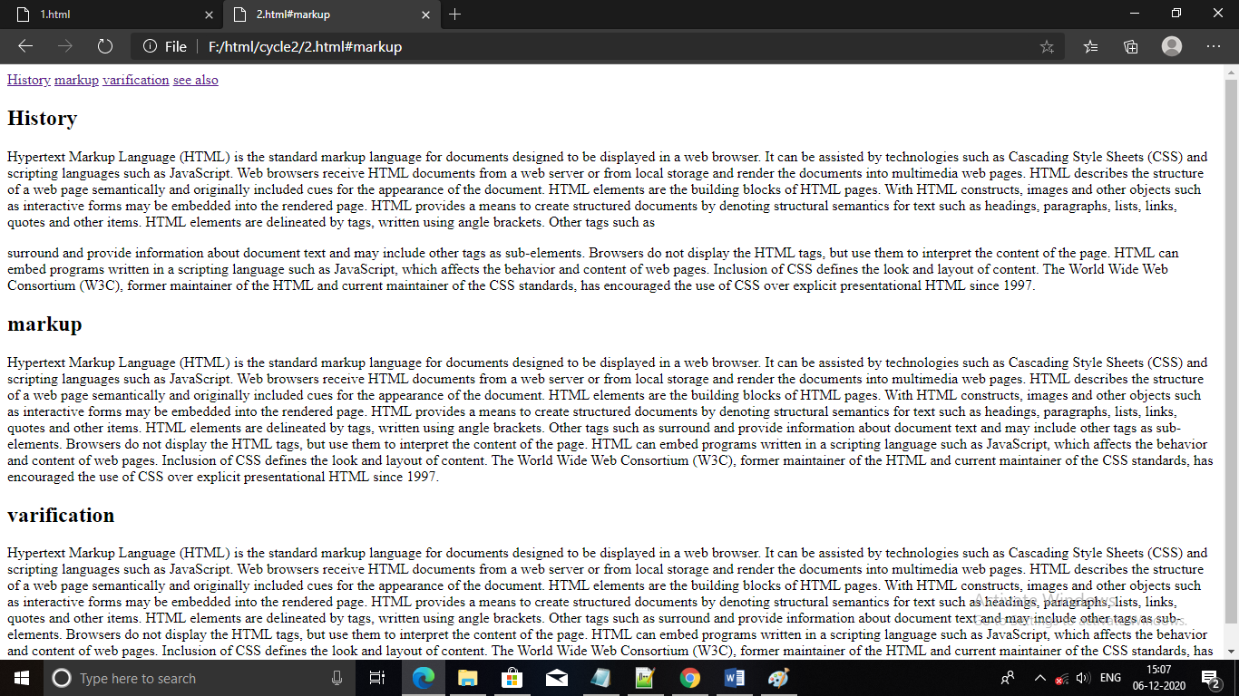

1. Display three different images. Skip two lines between each image. Each image should have a heading.

Answer:

<html>

<head>

<title> </title>

</head>

<body>

<figure>

<img src="1.jpg" style width="30%" height=40% ><br><br>

<figcaption >

Beautiful girl with beautiful hair and eyes

</figcaption>

<img src="3.jpg" style width="30%" height=40%"><br><br>

<figcaption>

The Maldives are home to some of the world's most ravishing islands.

</figcaption>

<img src="2.jpg" style width="30%" height=40%">

<figcaption>

Beautiful white colour cat with blue eyes.

</figcaption>

</figure>

</body>

</html>

Output: 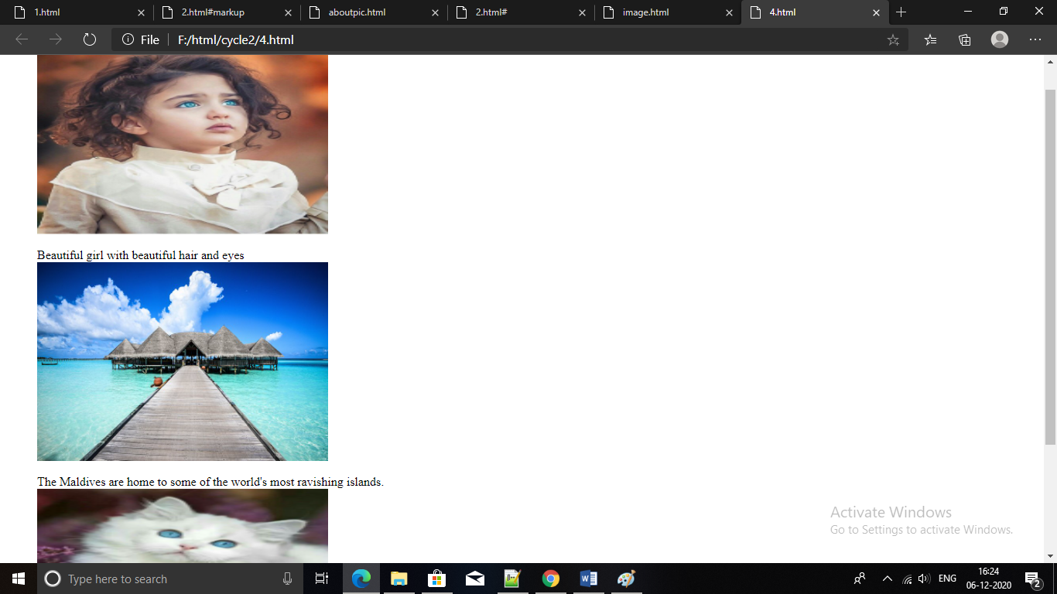

1. Display an image that when clicked will link to a search engine of your choice in a different window

Answer:

<html>

<body>

<a href="http://www.google.com" target="_blank">

<img src="cat.jpg" alt="cat" />

</a>

</body>

<p>

click on the image to be taken to the yahoo search engine.

</p>

</html>

Output:

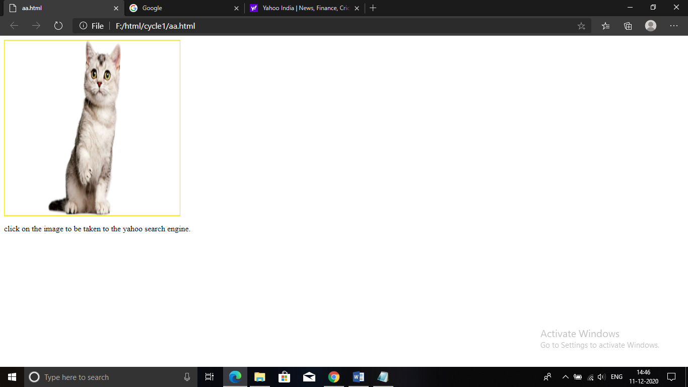

1. Create the following Html Page using appropriate form controls

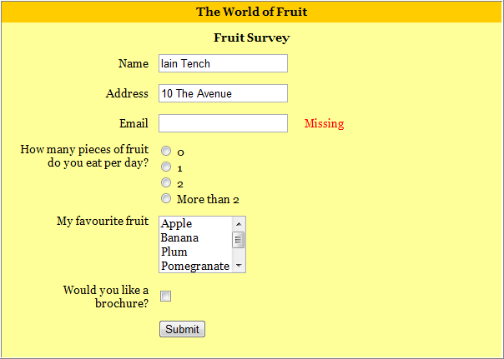

Answer:

<html>

<head>

<title> Registration Form</title>

<style>

.div_1 { background-color:orange;margin:10px; }

.div_2 { background-color:yellow;margin:10px; margin-top:-22px; }

</style>

</head>

<body >

<div class="div_1"><h1><font size="5" style ="margin-left:293px;"> The world of fruit</font></h1></div>

<div class="div_2"><h1><font size="3" >

<form style="height:560px;">

<h2 style align="center"> Fruit survey</h2>

<table>

<tr>

<td>

Name

</td>

<td>

<input type="text" placeholder="Name" name="">

</td>

</tr>

<tr>

<td>

Address

</td>

<td>

<input type="text" placeholder="Address" name="">

</td>

</tr>

<tr>

<td>

Email

</td>

<td>

<input type="email" placeholder="Email" name=""> Missing

</td>

</tr>

<tr>

<td>

How many peice of fruit<br>

do you eat per day?

</td>

<td>

<input type="radio" name="fruit">0<br>

<input type="radio" name="fruit">1<br>

<input type="radio" name="fruit">2<br>

<input type="radio" name="fruit">more than 2

</td>

</tr>

<tr>

<td>

My favourite fruit

</td>

<td>

<select multiple>

<option value="">Apple</option>

<option value="">Banana</option>

<option value="">Plum</option>

<option value="">Pomegranate</option>

<option value="">Orange</option>

<option value="">Grape</option>

</select>

</td>

</tr>

<tr>

<td>

Would you like a<br>

brochure?

</td>

<td>

<input type="checkbox" name="fruit">

</td>

</tr>

<tr>

<td>

<input type="Submit"value="submit" name="">

</td>

</tr>

</div>

</form>

</table>

</body>

</html>

Output:

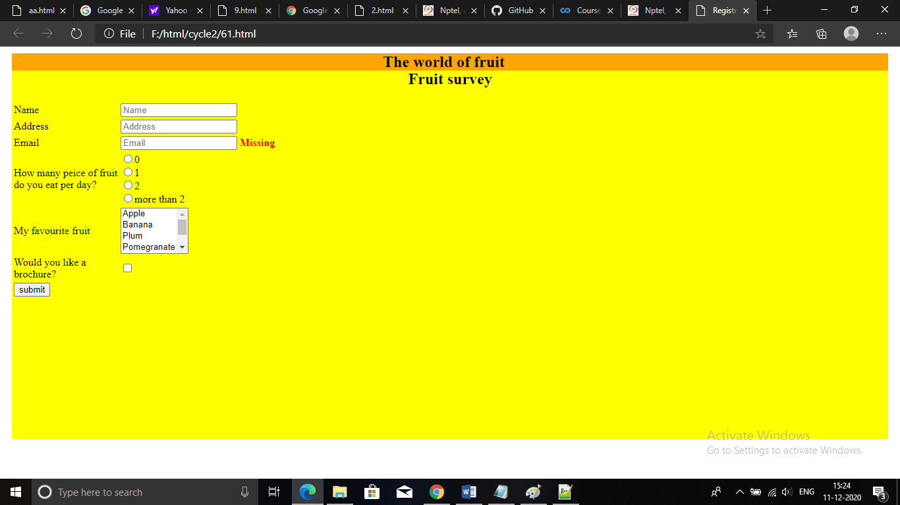

1. Create an image map for ‘Kerala Map’. Map at least 3 districts so that when you click on that particular district the details regarding that district(**eg: population, Area, Tourist Spots(with images), Monuments, Interesting Facts )** should be displayed on a new page.

Answer:

<html>

<head>

<center>

<body>

<h1><u><font color="gray" face="cooper">KERALA MAP</font></u></h1>

<map name="kerala">

<area shape="rect" coords="300,440,470,500" href="ernakulam.html"/>

<area shape="rect" coords="324,451,395,501" href="kottayam.html"/>

<area shape="rect" coords="402,358,469,499" href="idukki.html"/>

</map>

<img src="kerala.png" alt="kerala" usemap="#kerala"/>

</center>

</body>

</head>

</html>

Ernakulam:

<html>

<head>

<style>

.div_1 { background-color:red;margin:20px; }

.div_2 { background-color:yellow;margin:20px; }

</style>

</head>

<body>

<center>

<br>

<div class="div_1"><h1><font color="white" size="6" face="Cooper"> ERNAKULAM</font></h1></div>

<div class="div_2"><h1><font color="green" size="6" face="Comic sans MS">

<h1><u>POPULATION</U></H1>

<P>Ernakulam (IPA: /eːrɐɳaːkʊɭɐm/; IAST: Eṟaṇākuḷaṁ) is a district of Kerala, India. Situated in the central part of the state and spanning an area of about 3,000 square kilometres (1,200 sq mi), Ernakulam district is home to over 9% of Kerala's population. Its headquarters is located at Kakkanad. </P>

<h1><u>AREA</U></H1>

<P> 30.63km<sup>2</sup></P>

<h1><u>TOURIST SPOTS</u></h1>

<h2>CHERAI BEACH</h2>

<img src="cheraibeach.jpg" alt="beach" height="260" width="525"/>

<P>Cherai Beach is a beach located in Cherai in the northern side of Vypin Island, a suburb of the city Kochi in the state of Kerala, India. One of the most visited beaches in the state, it is situated at around 25 km from downtown Kochi and 20 km from Cochin International Airport. </P>

<h2>MATTANCHERY PALACE</h2>

<img src="mattanchery.jpg" alt="palace" height="260" width="525"/>

<P>The Mattancherry Palace is a Portuguese palace popularly known as the Dutch Palace, in Mattancherry, Kochi, in the Indian state of Kerala which features Kerala murals depicting portraits and exhibits of the Rajas of Kochi. The palace was included in the "tentative list" of UNESCO World Heritage Site.</p>

</div>

</body>

</html>

Output:

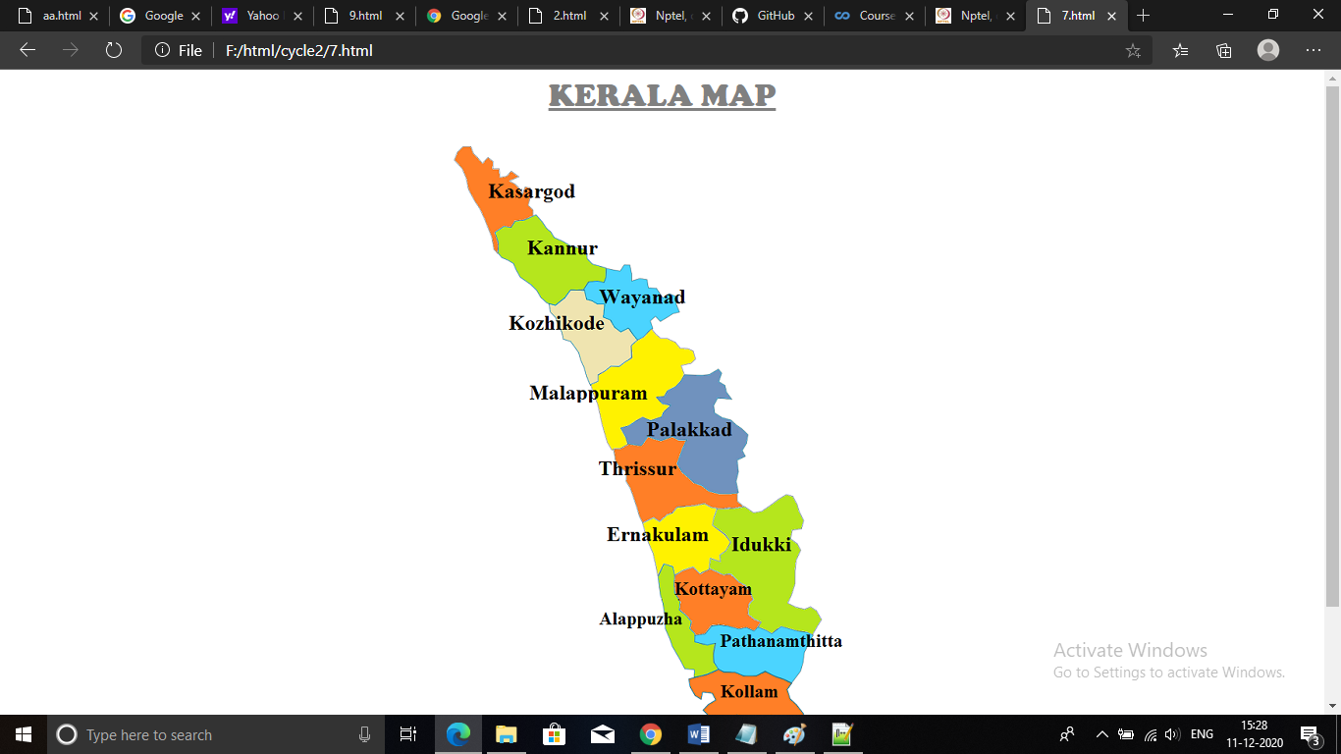

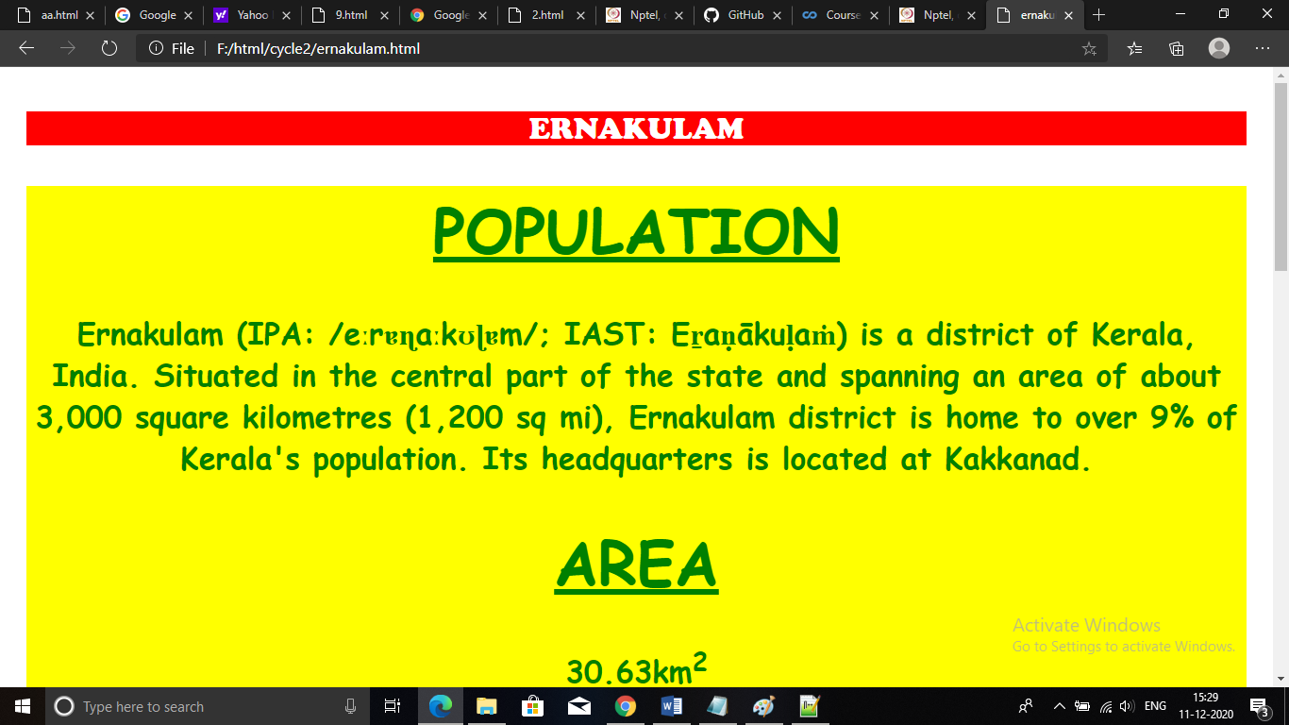

1. Construct this puzzle looking thing

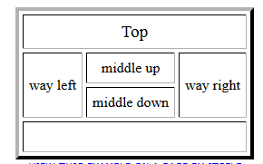

Answer:

<html>

<head>

<title> </title>

</head>

<table border="1">

<tr >

<td colspan="3"> &nbsp;&nbsp;&nbsp;&nbsp;&nbsp;&nbsp;&nbsp;&nbsp;&nbsp;&nbsp;&nbsp;&nbsp;&nbsp;&nbsp;&nbsp;&nbsp;&nbsp;&nbsp;&nbsp;&nbsp; Top</td>

</tr>

<tr >

<th rowspan="2">Way left</th>

<td>Middle up</td>

<th rowspan="2">way right</th>

</tr>

<tr>

<td>Middle down</td>

</tr>

<tr>

<td colspan="3"> <br> </td>

</tr>

</table>

</body>

</html>

Output:

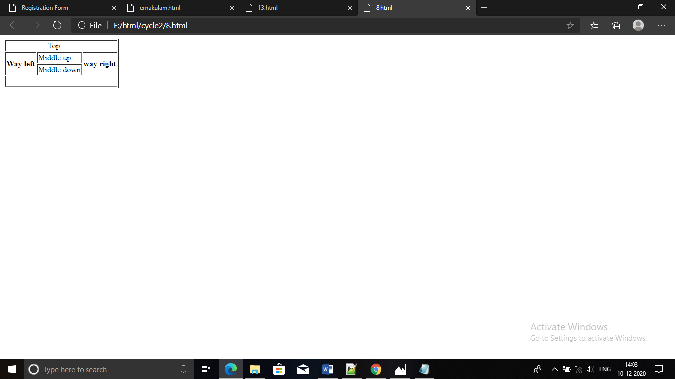

1. Make up three image links for 3 web browsers and put them in a borderless table. Construct the table so that there is just a little space between the images.

Answer:

<html>

<head>

<body>

<br><br>

<table align="center" style="border-collapse:collapse;">

<tr>

<td><a href="https://www.firefox.com/" target="_blank">

<img src="mozilla.png" alt="firefox" height="220" width="200" style="margin-left:76px"/>

</td>

</tr>

<tr>

<td><a href="https://www.google.com/chrome/" target="_blank">

<img src="chrome.png" alt="chrome" height="220" width="350"/>

</td>

</tr>

<tr>

<td><a href="https://microsoft.com" target="_blank">

<img src="microsoftedge.jpg" alt="edge" height="220" width="320"/>

</td>

</tr>

</table>

</body>

</head>

</html>

Output:

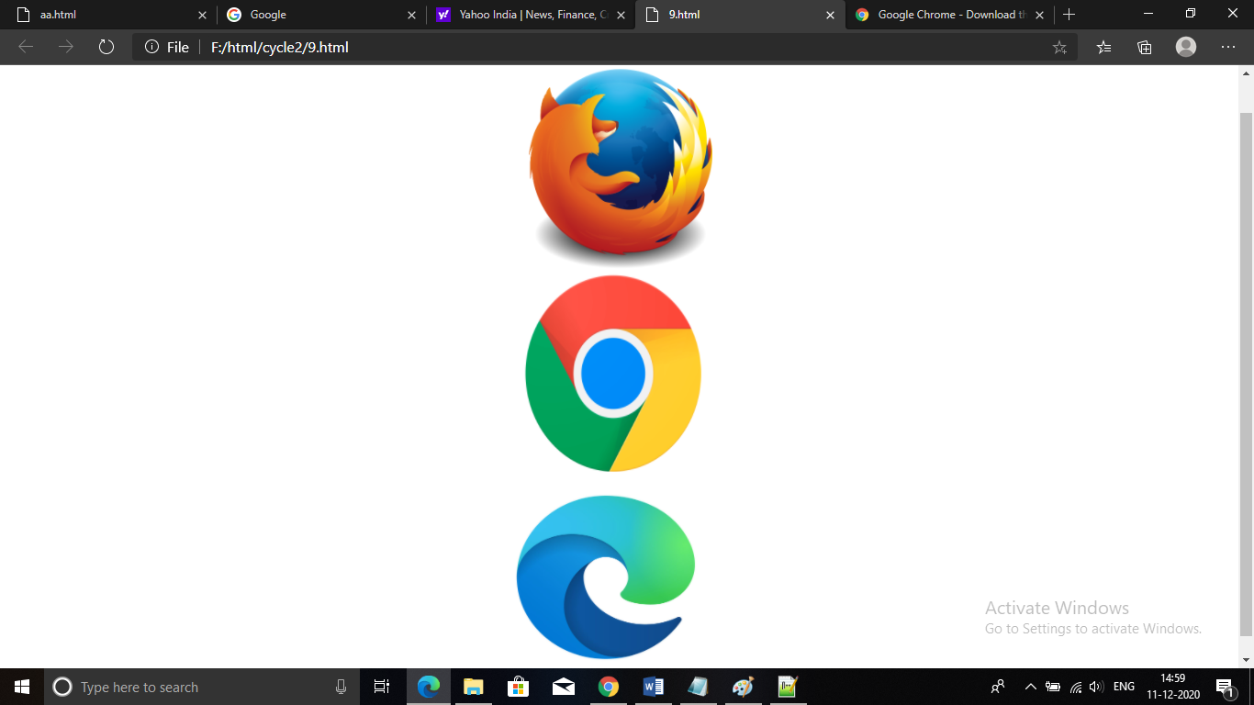

1. **Create the following html page using frames**

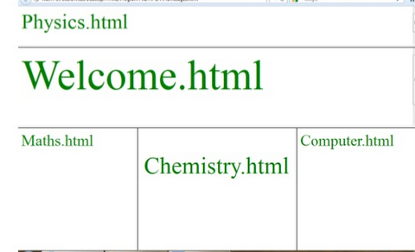

Answer:

<html>

<head>

<title> </title>

</head>

<frameset rows="10%,80%" >

<frame src="f1.html">

<frameset rows="30%,80%">

<frame src="f2.html" >

<frameset cols="40%,80%">

<frame src="f3.html">

<frameset cols="80%,80%">

<frame src="f5.html">

<frame src="f4.html">

</frameset>

</html>

Output:

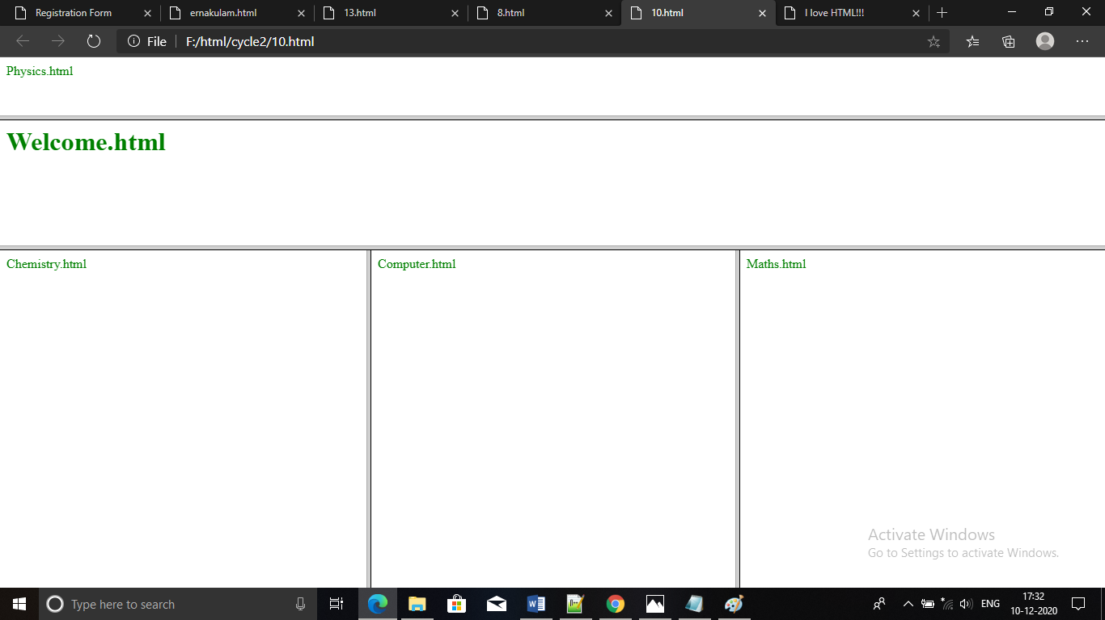

1. **Create an HTML page using frames which is similar to the following one.**

**In the left frame provide hyperlinks to 3 important monuments in world. On clicking that hyperlink an image of the monument should be displayed in right frame with suitable description**

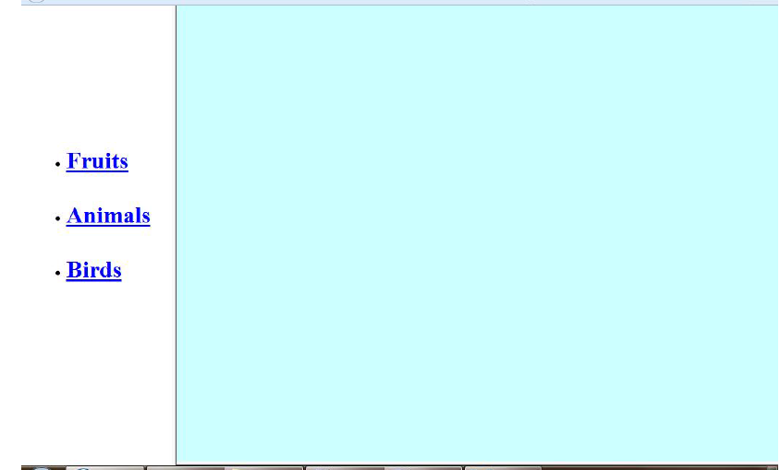

**Answer:**

<html>

<head>

<title> index </title>

<style>

.div_1{ background-color:yellow; margin:20px; }

.div_2{ background-color:grey; margin:20px; }

</style>

</head>

<body>

<center>

<br>

<div class="div_1"><h1><font color="green" size="6" face="Cooper">FRUITS,ANIMALS,BIRDS</font></h1></div>

<div class="div_2"><font color="white" size="6" face="Cooper">

<ul>

<li>FRUITS</li>

<li>ANIMALS</li>

<li>BIRDS</li>

</ul>

</div>

</center>

</body>

</html>

**Output:**

